Vehicle product market
Professor name
Institution affiliation
Student name
Date
Vehicle Product market
Vehicles are the most products that are sold in today's world. There are many factors which contribute to the development of motor vehicles in the world market. These factors are propelled by the fact that almost every country in global auto industries has set up required facilities in their country. They include; availability of fuel, Increase in population, Improved infrastructure has also motivated many people both from the producers and consumers of vehicles. (Murphy et al. 8)
(Murphy et al. 8) Argued that the differences are as a result of many factors including quality, speed differences material used in modeling, level of comfort and also fuel consumption. The different types of brands include; Toyota Nissan, Honda, Mitsubishi, Subaru, Volkswagen, BMW, Ford, Volvo, etc. Toyota is one of the vehicle brands highlighted above. It is popular in most countries of the world. Its popularity is as a result of its reliability. They are very classic especially in terms of comfort and driving. I can suggest that this brand of vehicle is unbeatable in the general market of cars. Secondly, Nissan brands manufacture has integrated their cars in terms of technology than other brands in the market like they provide various appliances with the continuously variable transmission (CVT).
Most of the people using these cars usually find them to be less reliable than Toyota brands. Thirdly, Subaru cannot be placed aside as another great brand of vehicles. It originated in Portland where it is viral; they are ranked second to Mazda when compared in terms of pleasure and balance on the road. They are the best brand of cars when it comes to off-road. They are also reliable just like Toyota brand and very comfortable. Long et al. 60, said that the prices of this brand of the vehicle depend on the purpose of the car since others are personal private cars, public cars, heavy tracks, etc. Regarding these, their prices, therefore, are different.
Those operating for commercial purposes are very expensive moving downwards up to private personal cars. Generally, prices also differ in terms of the quality, model, and level of comfort ability of the vehicle (Long et al. 60). The price range is entirely different, Mercedes-Benz goes at an average price of EU 47 243, followed by BMW EU 46 633, Volvo EU 44225, Audi EU 41619. Toyota and Nissan range at EU 24160, and EU 26176 respectively.
Purchasing recommendations
- Researching
Taking research is among the critical thing that one should take into consideration while in the processes of purchasing a vehicle brand. These help one to know detailed information about the brand he/ she is ready and willing to buy. Today researching about a vehicle brand is not difficult since most of the information about vehicle brands have already been feed into the internet and they can be accessed online. Most preferred sites that one can easily obtain information about the different brands of the vehicle are; consumers' information, Auto Traders, newspapers and mass media. They provide a variety of information about a particular brand like price range, model and purpose of the vehicle.
- Factor in insurance costs
When purchasing a vehicle, one is required to consider the insurance cost of the car brand he/she is buying. Some of them have very high insurance premiums. This can be brought by the type and purpose of the vehicle brand he/she is buying. For instance, if the spare parts of the car brand purchased cannot be easily accessed or if the band is a commercial type or public transport vehicle. Insurance cost is one of the significant losses in the overall costs of the car so people should consider this aspect in details. Insurance premium quotes can just be accessed online. One is only required to provide information about the brand and the purpose of the vehicle he/she has bought so that premiums can be calculated accordingly. Additionally, the sports car can be leading with high premiums followed by public service vehicles, conventional cars the heavy tracks because even the chances of them having an accident are very minimal.
- Test the vehicle by driving.
When one is purchasing a car, he/she is supposed to test the vehicle by driving while the dealer is beside him/her. The most important aspect of testing the car is looking at the level of comfort the buyer expected to have. Besides that, the following elements should also be considered; the car should be quiet and very smooth, for control one can test flip on air, turning on windshield wipers, switches, buttons and lastly breaks and accelerator.
- One should not buy the extended warranty.
When purchasing a car, one should also consider the guarantee of the car brand. The worst warranty is those offered by the dealers. They are in most cases expensive, and their coverage is often limited since they do not cover the cost of many types of mechanical failures that might arise in the vehicle. Manufactures warranty are preferred because they provide ample coverage for the car. (Sharma et al. 13).
- Do not purchase the Add-ons.
(Sharma et al. 13) Proposed that add-ons are additional accessories that are modified either inside or outside the vehicle. Sometimes they are costly to purchase and install them since they can cost the buyer a lot of money. One is therefore advised to minimize the modifications if he/she wants.
In most cases, these modifications are applied in public transport vehicle, sports cars and some of the personal vehicles. They are used with the aim of attracting passengers for the case of public transport vehicles. Heavy trucks and tractors don't need those modifications.

- Avoid impulse buying
An according to (Wu et al. 170) the consumers of motor industry are strictly advised to avoid being impatient especially when purchasing the car brand. People should commit themselves to intensive research activity before buying a vehicle. For instance, one might be looking at a new Mercedes-Benz from a dealer, but they are not available at that. Instead of being patient and wait until it is brought to the market, he decides to buy a Volvo brand at a lower price and making it worse it might lack some of the features he wanted. Researching helps one to identify the make, model, and style of the car brand and also to review the insurance rate to be paid.

Sources of recommendations
- Online research panel
Most of the recommendations are freely available online. There are many websites which are dealing with issues related to purchases of new vehicle brands and instruction are also provided accordingly concerning the different brands available. Through the internet, information about different brands of vehicles can be displayed, their condition of purchase, their prices, features, and model are shown. This exists because there are many dealers on-air selling these different brands of vehicle and they are competing in the global market so that they can have high sales worldwide. (Wu et al. 170).
- Real consumers.
Consumers are the closest people who provide information about the different types of vehicle brands. They are the real buyers and drivers of these brands. Therefore, they have a lot of information about them in general.
- Newspapers.
Newspapers also provide a variety of information about the different types of vehicle brands. They display information on publications may be when describing a particular brand of the vehicle, especially when highlighting the advantageous side of the brand so that the majority can be attracted to it. In most cases, the dealers are the ones who are taking their plea to the nation's centers for their brand to be displayed. (Wu et al. 170).

- Advertisements
Almost 80 percent of the source of information is obtained through publications. The information about a particular brand is displayed in various sites of social media. Televisions are the most known sites for adverts because the majority of the population get accessed to it. Social sites such as Facebook, Instagram, What Sapp, and other sites are also well known for providing information about the different types of brands.
- Marketing intelligence platform
Yang et al. 1285 propounded that, many of the motor vehicle companies use intelligent platforms to display the various brands of vehicle and their model produced and taken to the market. They are free to access, and they also provide clear information about the description of their product that is in the market. For example, the Lexus ES industry was upgraded to Toyota Camry, European Ford, Mazda 3 and the Volvo S40.
- Outsourcing providers
They are merely like customer cares at the respective brands of vehicle. They provide information about the brand of the vehicle one might have requested in details. In most cases they are friendly, and they care a lot about their customers.
- Library
Information on recommendations about a particular product like vehicle can also be gathered in libraries. Books inside the library also provide a lot of information about the different types of cars in the world market. Remember that vehicle existed many years before. Some of the books have been published individually to describe the evolution of different types of vehicle brands. Most of the people in recent years have produced trade journals about different brands of vehicles just by conducting consumer surveys at regular intervals and recorded them in books. Information gathered from the library are valuable and usually have a clear description of the product one is looking for, but unfortunately, it is highly neglected by many people.
- Trade journals
Almost all of the motor vehicle industry producing different brands of vehicle produce their journal at regular intervals. However, these journals usually provide detailed information about new products/ brand or improvements about the new brand in the market, and also innovations, etc. for example, the Toyota brand has their journal produced after six months. But even other brands usually produce their journals so that they can pass information about their brand to the general public.
Below are images of vehicle brands.
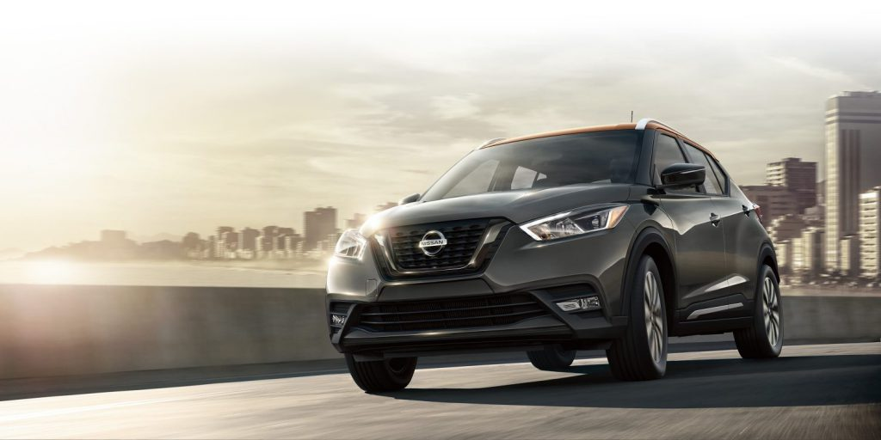

Nissan

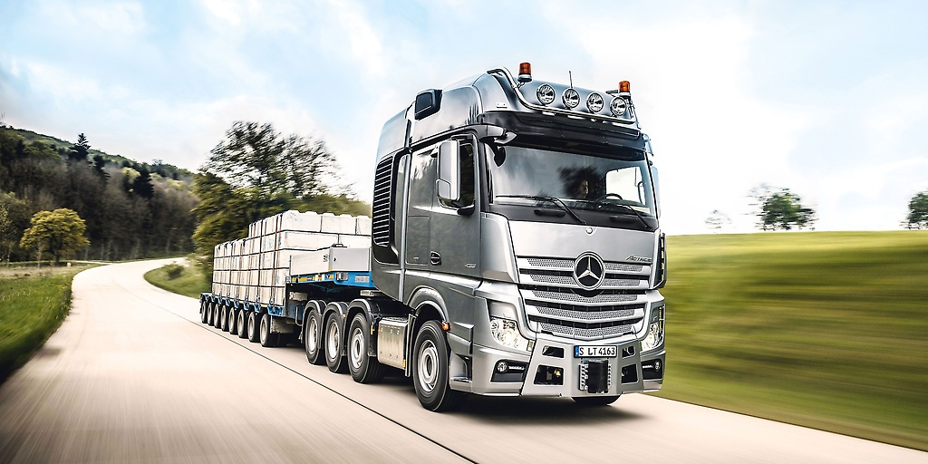

Mercedes commercial long truck
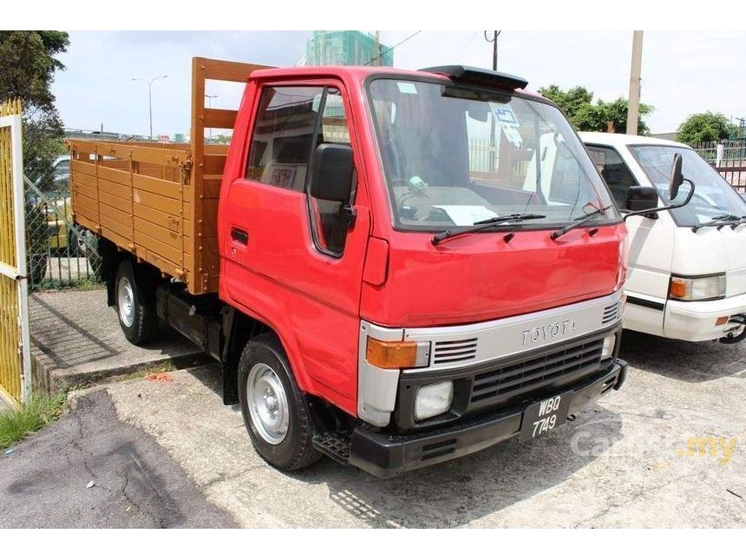
Toyota commercial lorry.
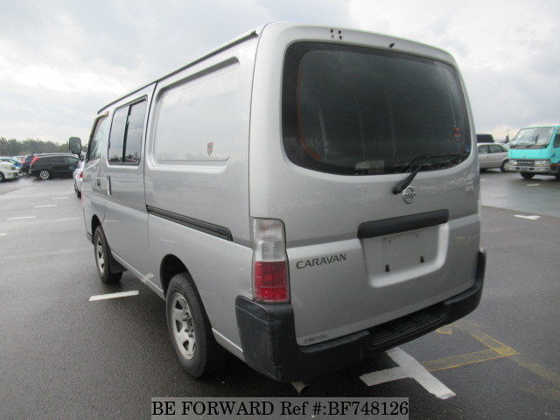
Nissan caravan public service vehicle.
Work Cited
Long, Zoe et al. "Latent demand for zero-emissions vehicles in Canada (Part 1): Insights from a design space exercise." Transportation Research Part D: Transport and Environment 67 (2019): 51-66.
Murphy, Finbarr, et al. "The impact of autonomous vehicle technologies on product recall risk." International Journal of Production Research (2019): 1-14.
Sharma, Sai Aarti, and Akanksha Aggarwal. "Aspects of marketing strategy impacting the commercial vehicle industry–A critical review of the literature." (2019).
Wu, Fang, et al. "Brand Name Types and Consumer Demand: Evidence from China’s Automobile Market." Journal of Marketing Research 56.1 (2019): 158-175.
Yang, Dong-xiao, et al. "The government regulation and market behavior of the new energy automotive industry." Journal of Cleaner Production 210 (2019): 1281-1288.

